The Earth has been warming over the past years. The warmest global mean temperature occurred in 1998. For the past 30 years, there has been a strong warming trend. Last year alone was the fourth warmest year. This could be because of the increase of greenhouse gasses in the atmosphere. The year to year variability could be due to short term climate affects such as volcanic eruptions and whether or not the year is a strong El Nino year.

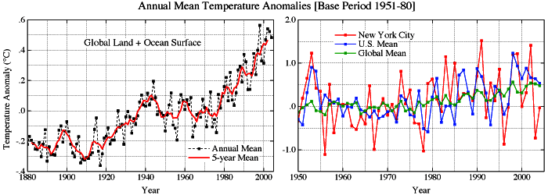
Picture: from “Earth gets a Warm Feeling all over” showing the increase of global annual mean temperature

Because the Earth receives more solar shortwave energy than the terrestrial longwave radiation that goes out to space, the Earth is out of energy balance. A result of this is the probability that the year 2005 will be even warmer than 2003 or 2004 and that it may even surpass 1998.
Every year the U.S. emits 6.6 tons of greenhouse gasses per person per year. This has increased 3.4 percent since 1990. Most of these greenhouse gasses (82%) are from burning fossil fuels.
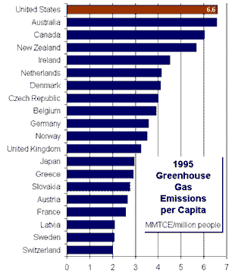Shows that the US leads the world greenhouse gas emission per person
Greenhouse gasses increase the temperature of the Earth by absorbing longwave and a few of the also absorb shortwave radiation and emitting it back to Earth, which increases the energy received at the surface. These gasses include water vapor, carbon dioxide, methane and ozone.
Carbon dioxide is at its highest levels in over 400,000 years, and it has increased 31% in the past 250 years. Methane is also at its highest levels in over 400,000 years, and it has increased 150% in the past 250 years. Nitrous oxide is at its highest levels in 1,000 years.
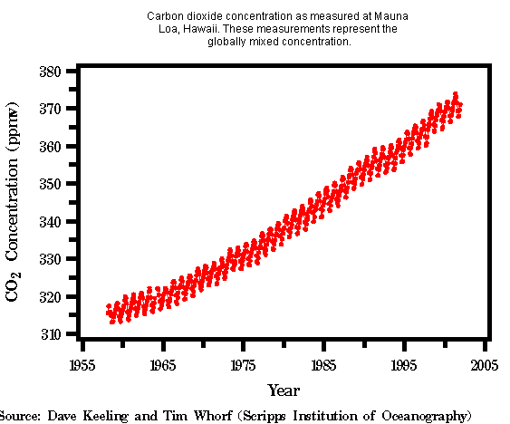Picture: from http://www.ncdc.noaa.gov/oa/climate/globalwarming.html#Q9
We can already see some effects of global warming such as the melting of ice sheets and also the increase in sea level. Sea level today is rising at a rate of two millimeters per year. However, 150 years ago the rate of sea level rise was only one millimeter per year, half of what it is today. The changes in ice volume are the cause for this rise is sea level. The snow cover in the northern hemisphere has been below average for nearly 20 years and has decreased 10% since 1966. This is due to the decreased snowfall in spring and summer. The glaciers have decreased in length. The following figure shows the current length of the glaciers. In the Arctic the ice cap has decreased by about 20% in the past three decades.

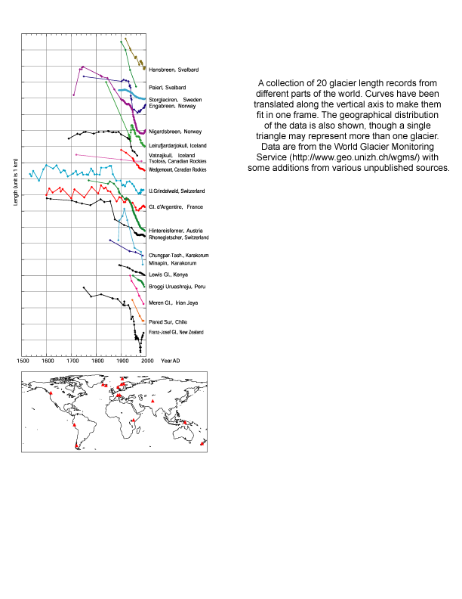From http://www.ncdc.noaa.gov/oa/climate/globalwarming.html#Q9 showing the current lengths of glaciers

The Arctic is warming twice as fast as the rest of the world, and it has gotten 40 percent thinner in the past thirty years. By 2070, the ice in the Arctic is expected to disappear completely. Some of the ice shelves in the north part of Antarctica have collapsed recently, such as the Larson A ice shelf in January 1995 and the Larson B in 1998. The waters around Antarctica have warmed by 0.17 degrees Celsius, and in the Antarctic Peninsula the melt season has increased by two to three weeks in just the past twenty years. Also the penguin population has declined by about 33% in the past twenty five years. In the Canadian Rockies, the Athabasca Glacier has retreated one third of a mile in the past sixty years.
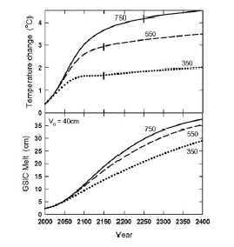Picture: from “Extended scenarios for glacier melt due to anthropogenic forcing”
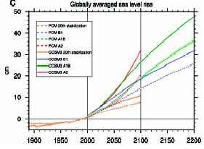Picture: from “How Much More Global Warming and Sea level rise” showing sea level rise

Hurricanes form in warm tropical waters. The water must be warm (at least 27 degrees Celsius. A thunderstorm changes into a hurricane through three stages: a tropical depression, a tropical storm, and then a hurricane. A tropical depression contains swirling clouds and not very fast winds. A tropical storm contains winds of 39 to 73 miles per hour. A hurricane has winds greater than 74 miles per hour. The winds converge at the surface and push warm, moist air up. There is a pressure gradient between the surface and at high altitudes, and there also is a continuing evaporation-condensation cycle. The high altitude winds must be blowing at a uniform speed. The hurricane season lasts from June 1 to November 3. The amount of damage of hurricanes has increased, while the total fatalities have decreased because we have better at forecasting them.

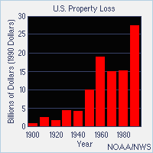
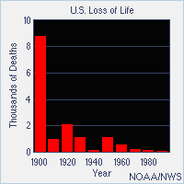

Picture: From http://science.howstuffworks.com/hurricane8.htm showing the increase in property loss and the decrease in deaths since 1900

In the northern hemisphere these storms rotate counter clockwise.

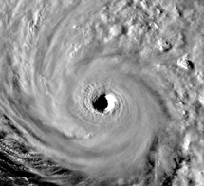Picture: from http://science.howstuffworks.com/hurricane8.htm shows a hurricane rotating counter clockwise

Hurricanes can produce strong winds, storm surges, flooding tornadoes and rip tides. According to the Saffir/Simpson scale, hurricanes are categorized according to their wing speed. A category 1 hurricane has winds 74-95 mph, and it causes damage to unanchored mobile homes and trees. A category 2 hurricane has winds 90-110 mph, and it causes damage to vegetation and some roofing material. A category 3 hurricane has winds 111-130 mph, and it can destroy mobile homes and causes some structural damage to small residences. A category 4 hurricane has winds 131-155 mph, and it causes major erosion of beach areas. A category 5 hurricane has winds greater than 155 mph, and it causes complete roof failure and also the evacuation of cities.
There is a relationship between hurricane intensity and frequency and increasing sea surface temperatures. Many people suggest that global warming is the reason for the increase in sea surface temperatures. In the tropical ocean sea surface temperature has increased by about 0.5 degrees Celsius between 1970 and 2004.
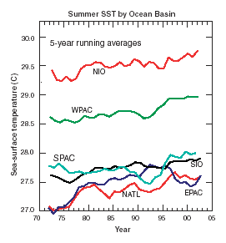Picture: from “changes in tropical cyclone number, duration, and intensity in a warming environment” shows that the sea surface temperature has been increasing since 1970

There is no increasing or decreasing trend in the frequency of hurricanes except in the North Atlantic Ocean. In the North Atlantic Ocean there is an increasing trend in the frequency of hurricanes and also in the duration of hurricanes.” The observation that increases in North Atlantic characteristics have occurred simultaneously with a statistically significant positive trend in sea surface temperature has led to the speculation that the changes in both fields are the result of global warming.”(P.J. Webster) In the Eastern Pacific, the number of storm days reached a maximum in the mid 1980s, and it has been generally decreasing ever since. However, in the west North Pacific, the sea surface temperatures have risen steadily, and the number of storm days reached a maximum in the mid 1990s. The number of cyclone days has decreased about 40 percent from 1995 to 2003.
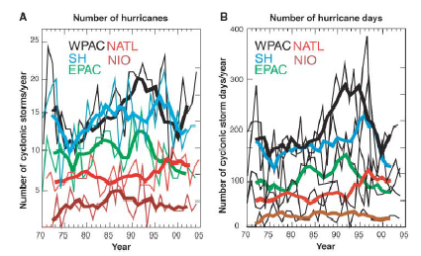Picture: from “changes in tropical cyclone number, duration, and intensity in a warming environment” showing the number of hurricanes and hurricane days

There is a change in the intensity of hurricanes. The actual number of category 1 hurricanes has remained roughly constant. However, as a percentage of the total number of hurricanes, it has decreased. There is a small trend in category 2 and category 3 hurricanes. However, category 4 and category 5 hurricanes, which are the strongest hurricanes, have increased. In fact, they have almost doubled. These changes are not just for one basin. The changes occur for all of them.
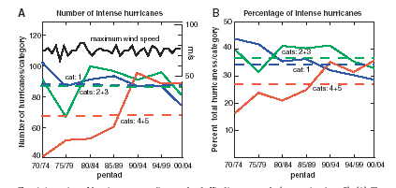

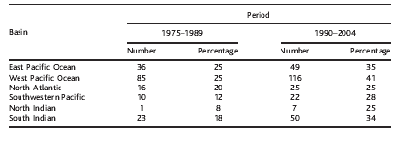Picture: from “changes in tropical cyclone number, duration, and intensity in a warming environment” showing that the intensities of hurricanes have been increasing

The total potential destructiveness of hurricanes can be based on the total dissipation of power after it is integrated over its lifetime, then, show that it is increasing and has increased since the 1970s. The power dissipation is determined by the following
Equation:
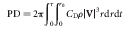]
CD is surface drag coefficient
p is the surface air density
[V] is the magnitude of the surface wind

If you simplify this equation, you can define the simplified power dissipation index to be:

V max is the maximum sustained wind speed

The power dissipation has more than doubled in 30 years in the Atlantic. In the west North Pacific it has increased by 75 percent, and when these two are combined, the power dissipation has almost doubled.

Atlantic
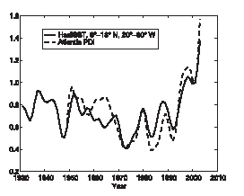
western N. Pacific
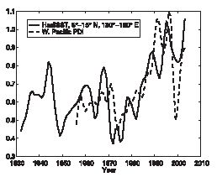
Combined:
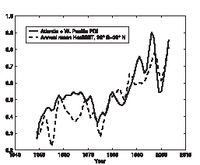
Pictures: from “Increasing destructiveness of tropical cyclones over the past 30 years” showing the PDI since 1930

If the sea surface temperature were to warm about 2.2 degrees Celsius, hurricane winds would be more intense by three to seven meters per second, which is five to twelve percent stronger, and the central surface pressure would decrease by seven to twenty millibars.
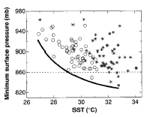Picture: from “Simulated Increase of hurricane intensities in a CO2-warmed climate” showing that as sea surface temperature increases minimum surface pressure decreases

There is a correlation between global warming and hurricanes. However the correlation does not lie with frequency, but it lies with hurricane intensities. These can be determined by power dissipation or wind speeds. Whichever way you use, it seems that hurricane intensity has been increasing as a response to an increase in sea surface temperature, which is increasing as a response to global warming.

Bibliography

Knutson, Thomas, Tuleya, Robert, Kurihara, Yoshio. Simulated Increase of Hurricane intensities in a CO2 Warmed Climate. Science, Volume 273, February 1998.

Emanuel, Kerry. Increasing Destructiveness of tropical cyclones over the past 30 years. Nature, Volume 436, August 2005.

Webster, P.J., Holland, G.J., Curry, J.A., Chang, H.R., Changes in Tropical Cyclone Number Duration and Intensity in a Warming Environment. Science, Volume 309, September 2005.

Wigley, T.M.L., Raper, S.C.B., Extended Scenarios for Glacier Melt due to Anthropogenic Forcing, Geophysical Research Letters, Volume 32, 2005.

Meehl, Gerald, How Much More Global Warming and Sea Level Rise? Science, Volume 308, March 2005.

http://science.howstuffworks.com/hurricane8.htm
http://www.climatehotmap.org/
http://www.ncdc.noaa.gov/oa/climate/globalwarming.html#Q9
http://yosemite.epa.gov/oar/globalwarming.nsf/content/emissionsindividual.html

The Dependence of Hurricanes on Global Warming
By: Tiffany Katerndahl

Abstract: Hurricane frequency doesn’t seem to correlate with increasing sea surface temperatures, which are a result of global warming. However, hurricane frequency does seem to correlate with an increase in sea surface temperatures by an increase in wind speeds and an increase in the amount of power dissipated by the hurricane.

